**Analysis Report of AI+ Club UI WhatsApp Group Chat From 2020-03-30 To 2021-02-15**

The Whatsapp group was created on the 30th of March 2020 by the club lead, Ernest Owojori. Between then and 15th of February when the analysis was made, 15039 messages have been sent to the group, this includes 898 media contents (Videos, Audios and images).

The most active member of the group is Ernest Owojori with 3775 messages sent, the bar chart below shows the Top five most active members of the group with the respective number of messages sent.

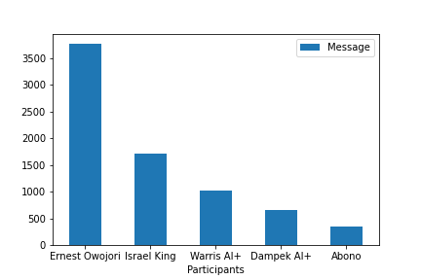

From the analysis, the most active time on the group is 9pm with a total of 1182 messages sent at this time, the second most active hour on the group is 8pm with a total of 1138 messages.

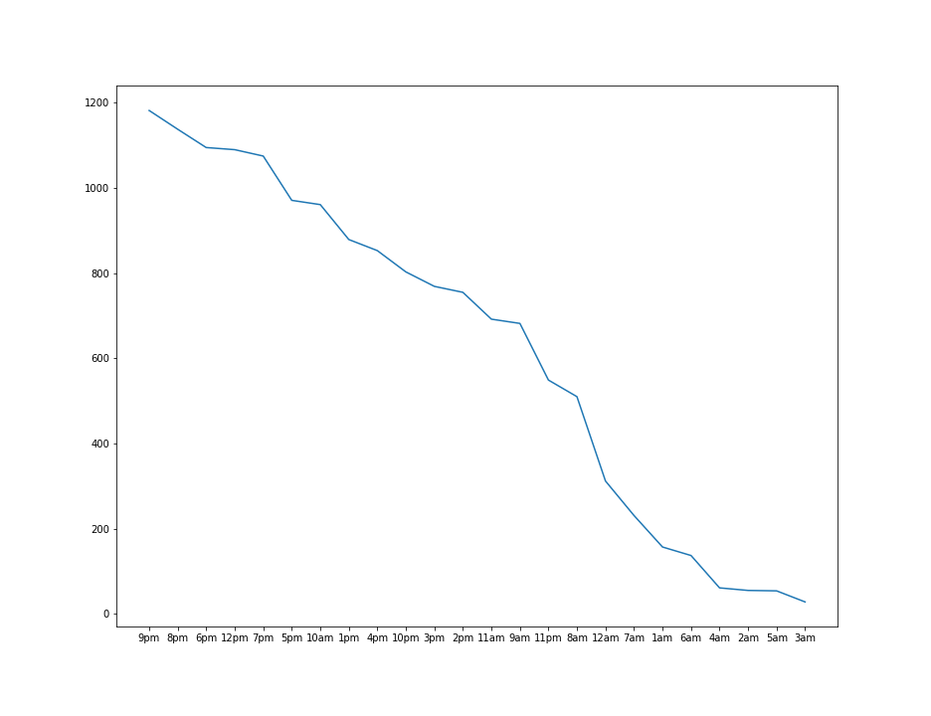

The most active month happens to be October with a total of 2563 messages, while the most active day of the month is 10th, the most active day of the week is Tuesday followed by Friday.

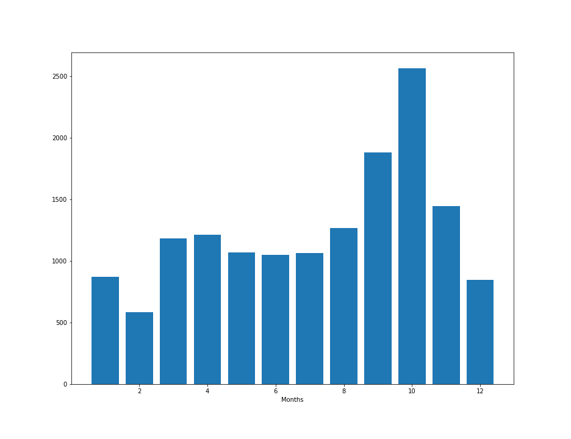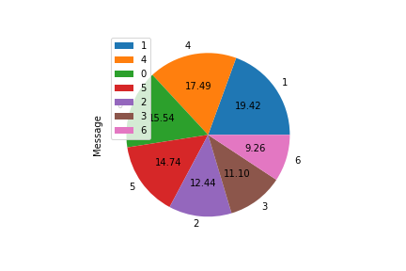

Monday:0, Tuesday:1, Wednesday:2, Thursday:3, Friday:4, Saturday:5, Sunday:6

Between the day of creation of the group and the day the analysis was performed are 322 days, of the 322 days there were 8 days of no recorded messages at all ( i.e the group had no chat on this 8 days), of the 314 days of active chat record, the day with the most number of messages sent to the group was on 2020-10-20;this happens to be the day of DSN 2020 Bootcamp opening ceremony. The second day with most number of recorded messages was on the 2020-03-30; which happens to be the day the group was created.

The Four most used words aside stopwords are: **ERNEST, LINK, DATA and ISRAEL**.

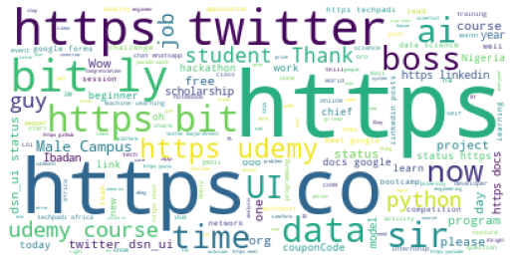

Word Cloud of Popularly Used Words